Assignment – Connecting Data

1. **Connecting store sales data**

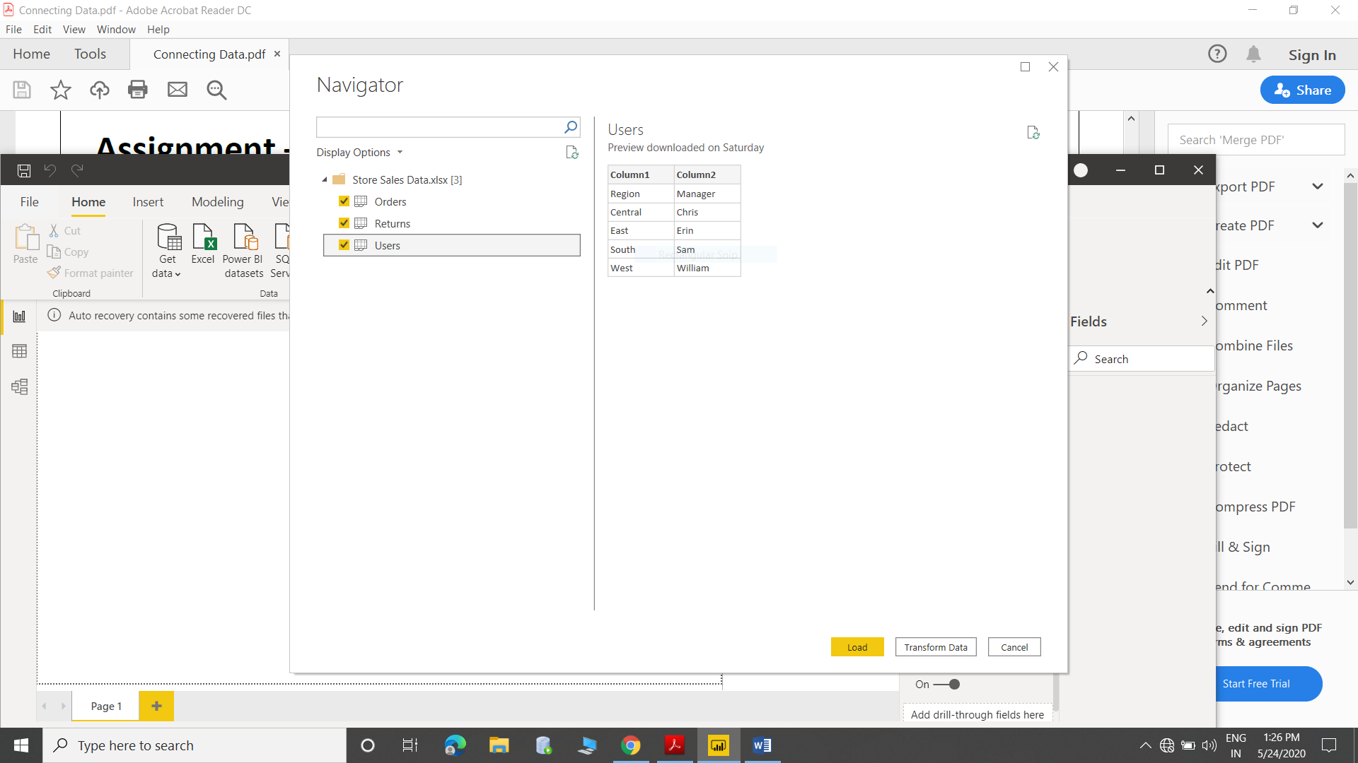

* Removed all the blank rows and updated column header

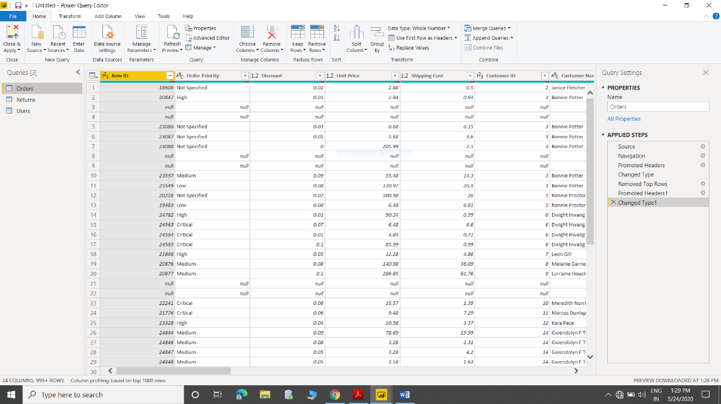

* Created text table

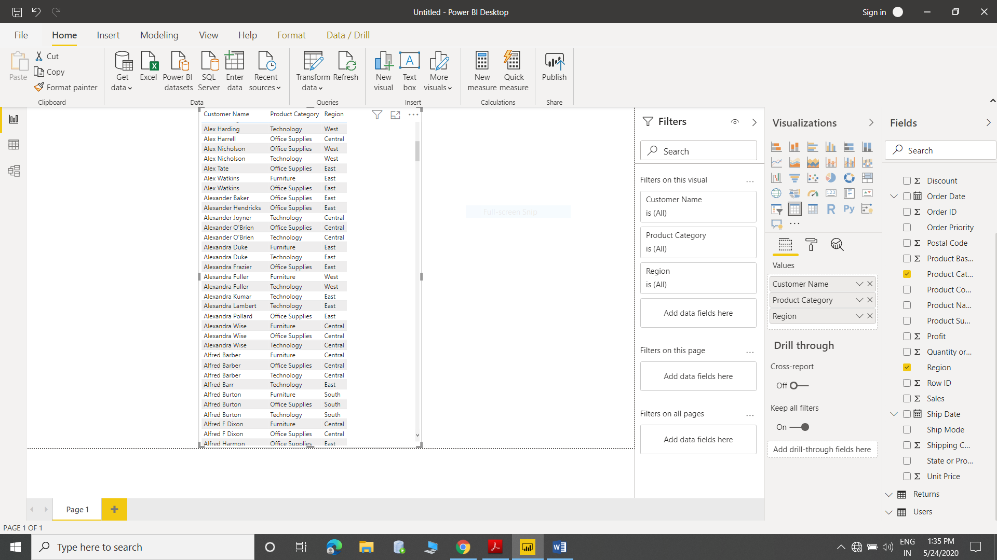

1. Line and Clustered column chart for sales and discount as per states (Highlighted highest state in technology)

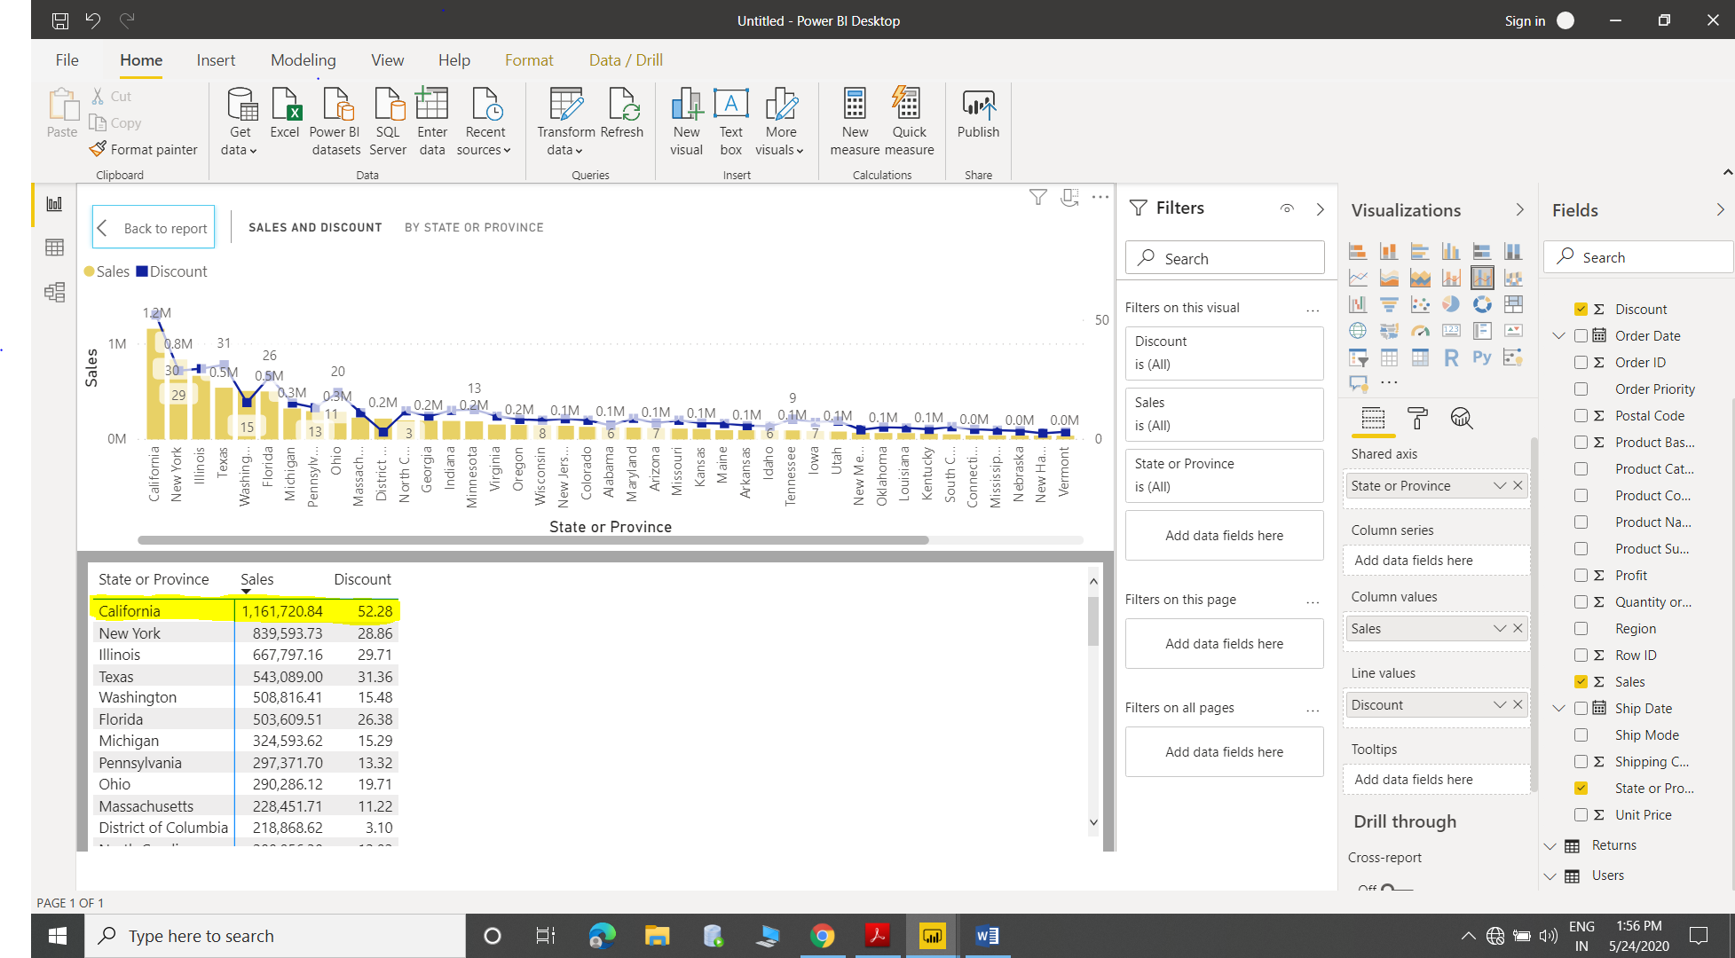

1. Created Donut chart

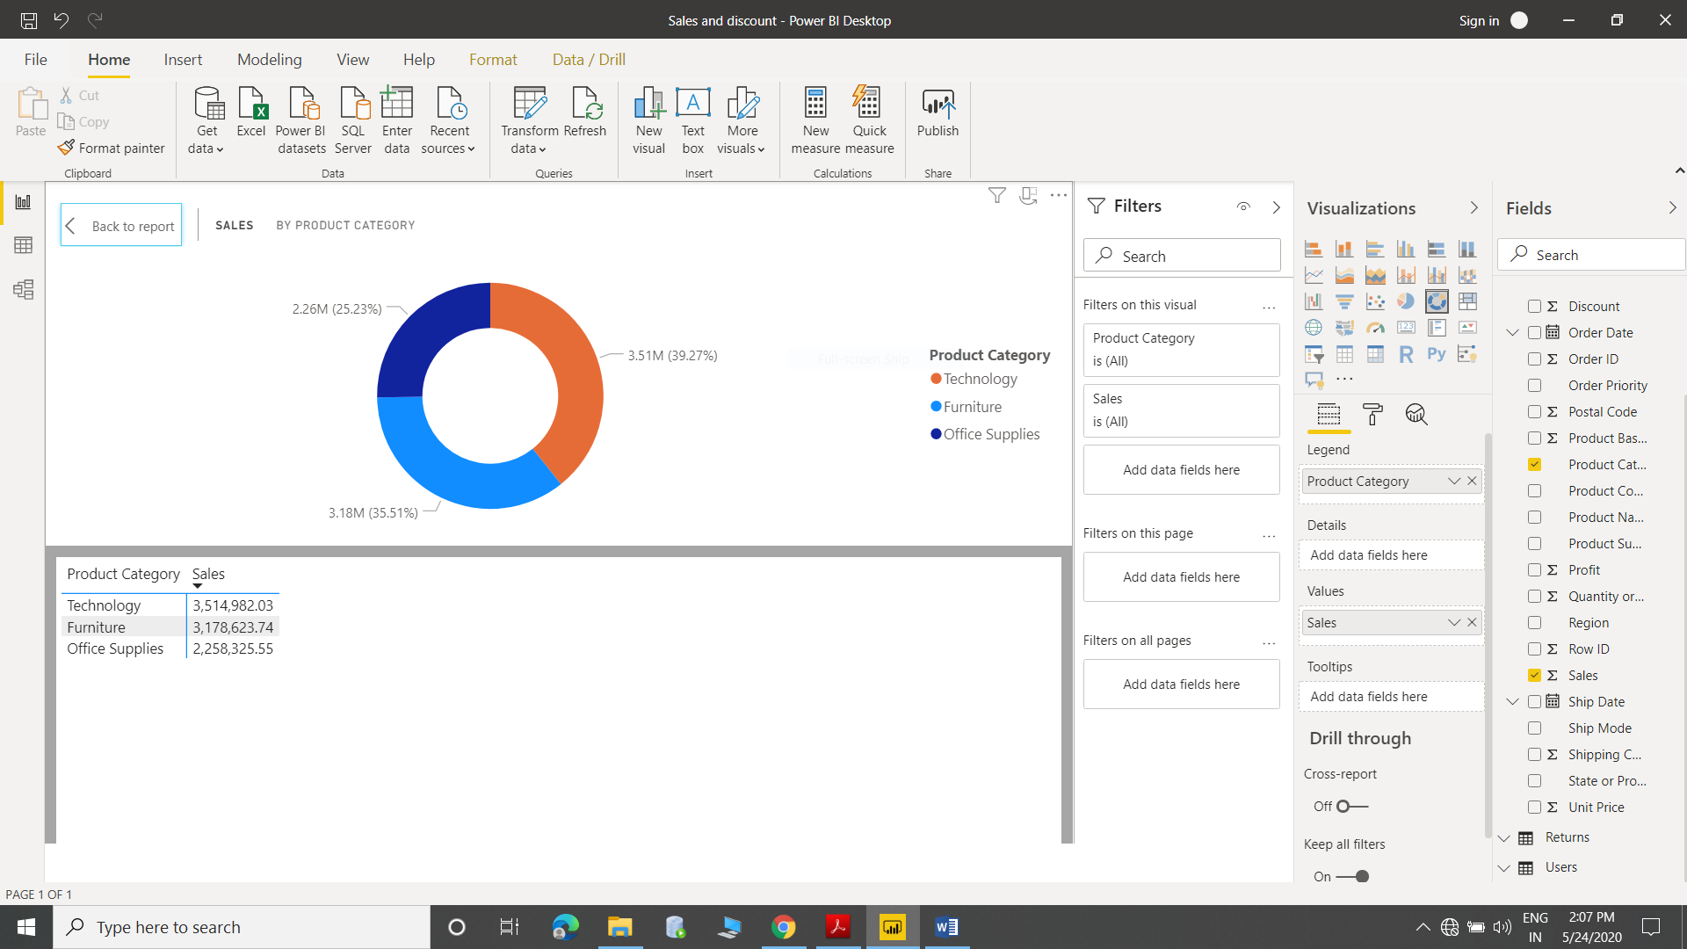

1. Slicer – Central

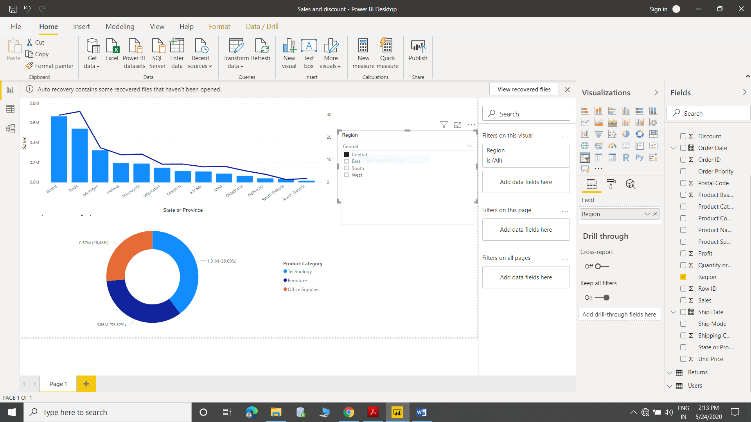

* Slicer –South

